Name: Omar Ghieh Project 2

Hello, the main idea of this website, company to give us internet, the first page is login, you can create new account by “Sign up”.

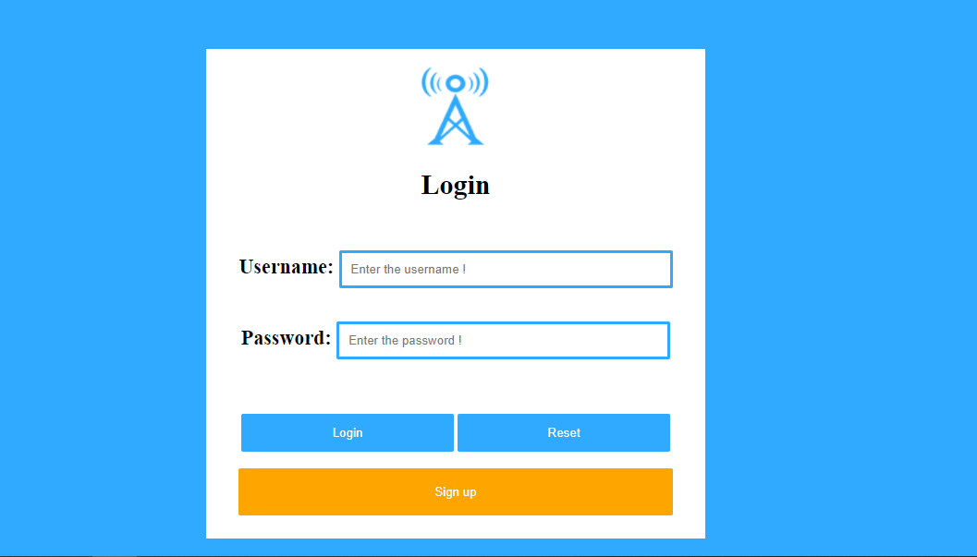

Write username, password, Email, and the speed of internet but write the speed of internet by KB, I wrote in placeholder, why should you write the speed of internet by KB, because when you write the speed, I wrote code to put automatically the Price in database.

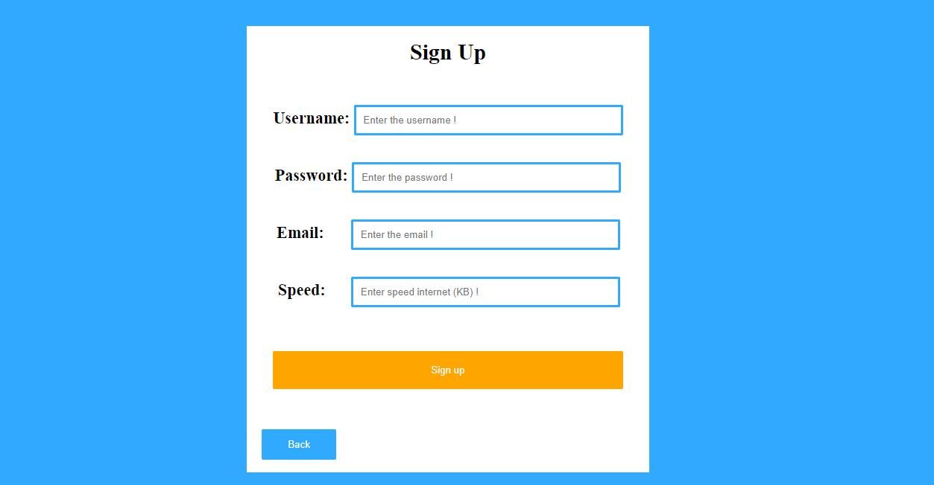

when you create new account you can log in, and write the username and the password, and you can go to the services page,

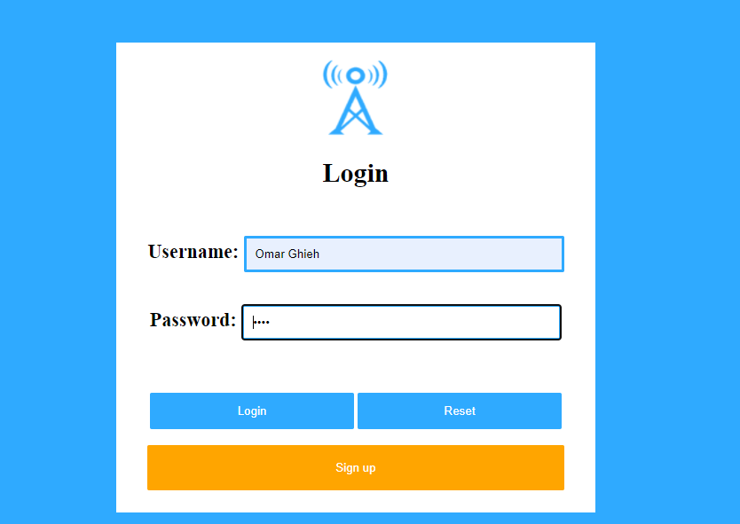

Services page, as you see we display all the data username and speed, and price, of all the users.

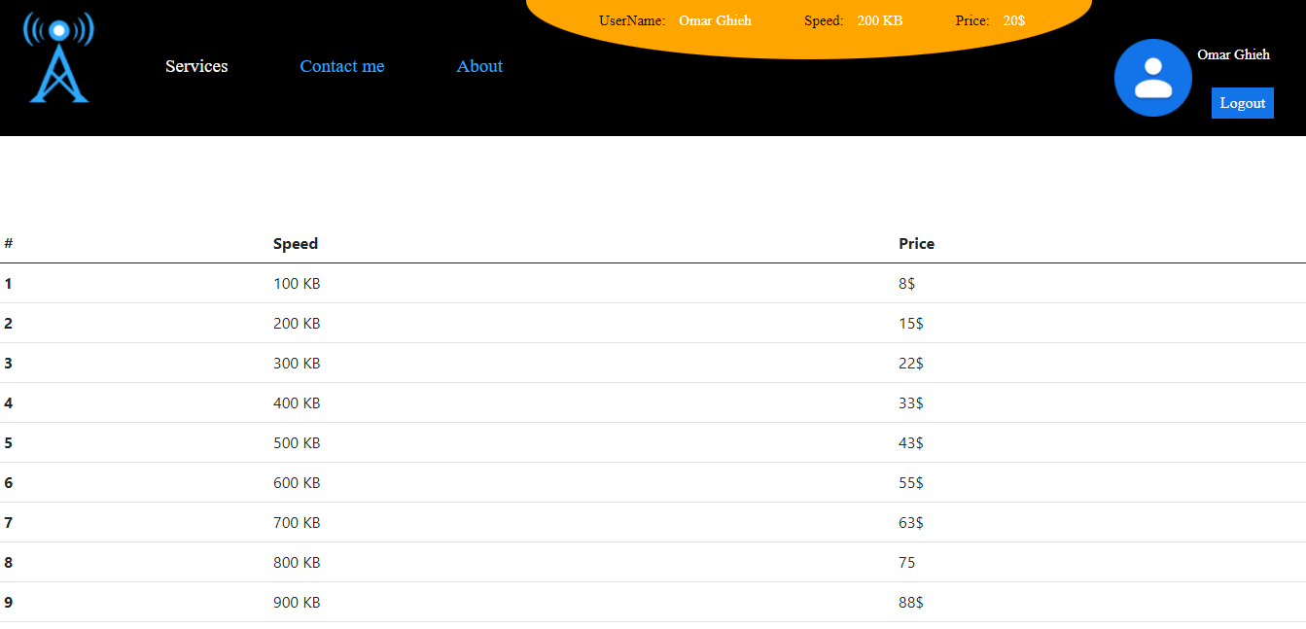

 I wrote code of this tool to calculate the speed of internet, if the user need the change the speed of internet, you can see the price of any speed.

These the best 5 websites to test speed of internet.

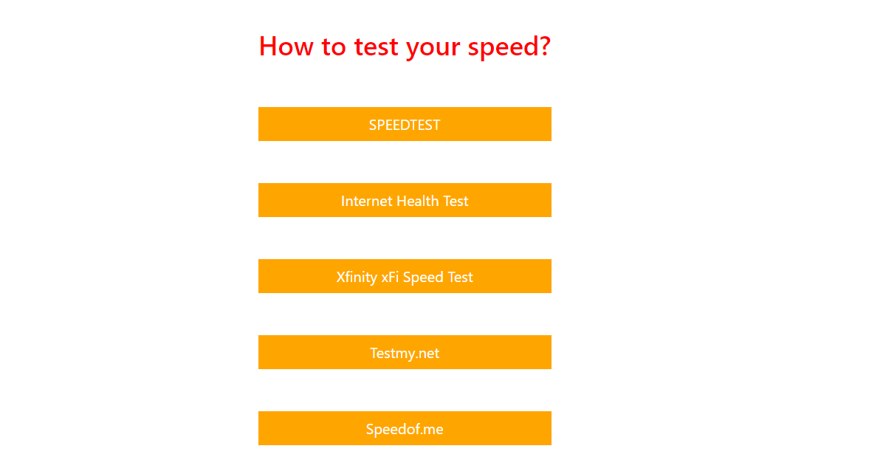

Contact me page, you should write the Email,Name,Message(problem), and if you like, put the screenshot of this problem, and click Submit.

The image will go to the file “problems”.

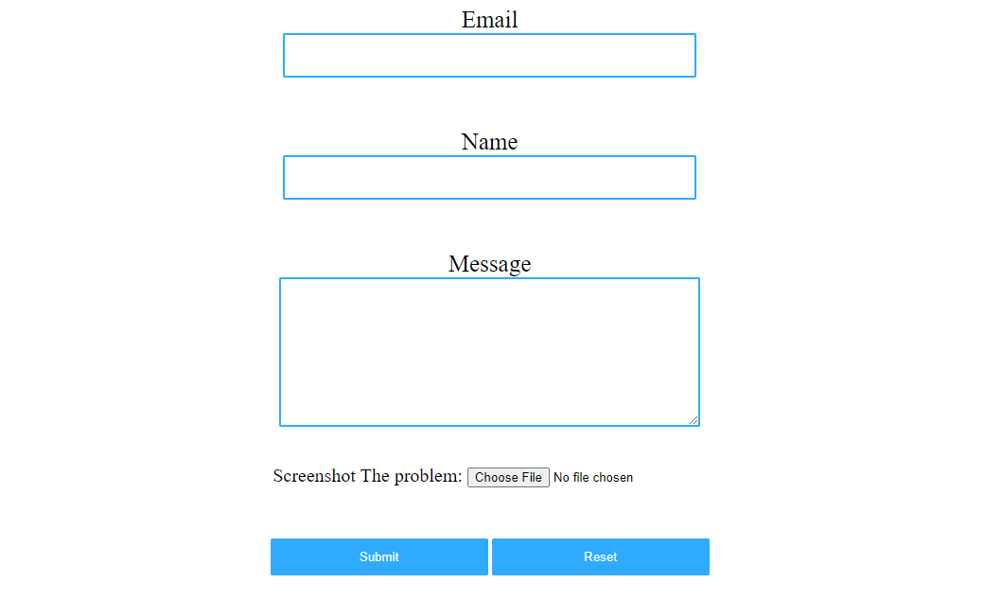

About page.

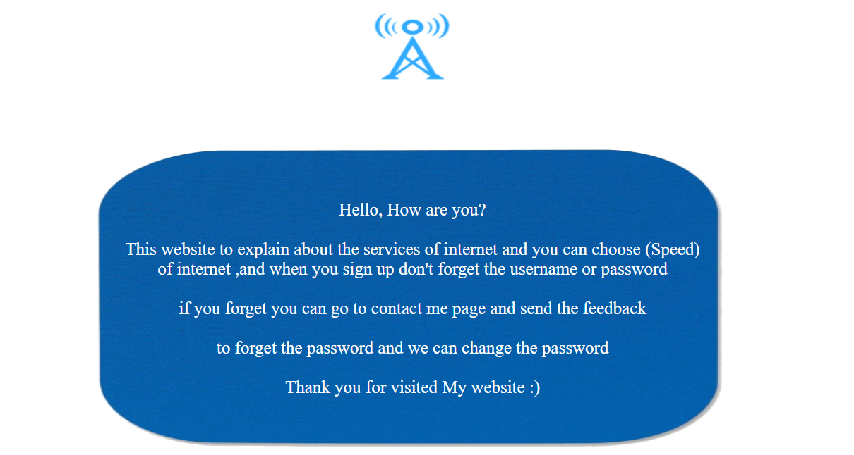

Now when you write in username and password “admin”, you can go to the admin page.

Admin page you can edit and delete any data, and when the user sends the problems in “Contact me”, you see all the problems and when you put “Solved” the problems will be deleted.

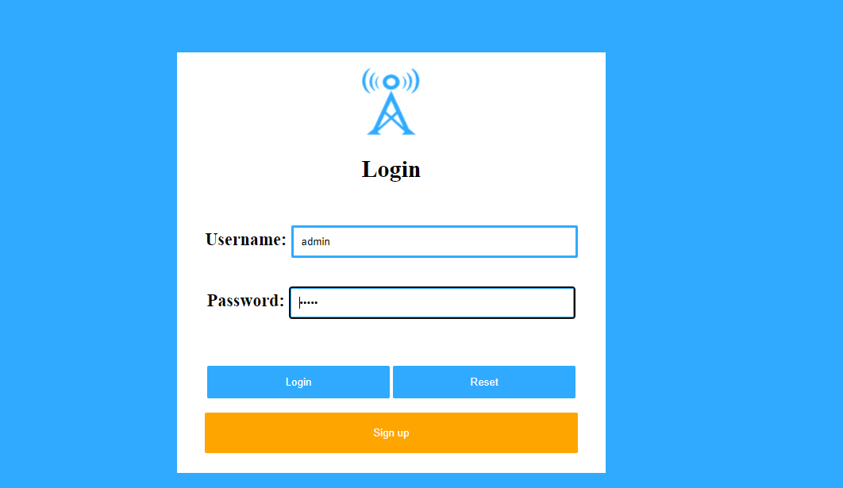

Users page, as you see, only admin can see this data of users.

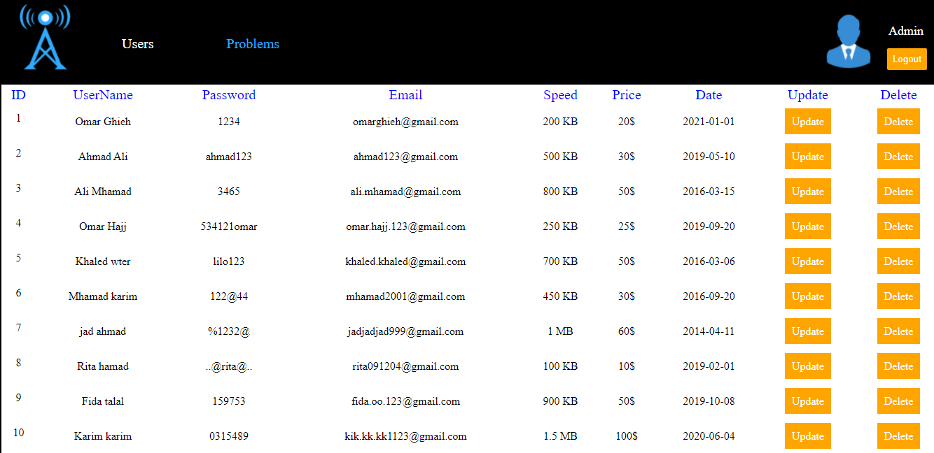

When you go to problem page, you can see all the problems of users.

I sent this problem for example.

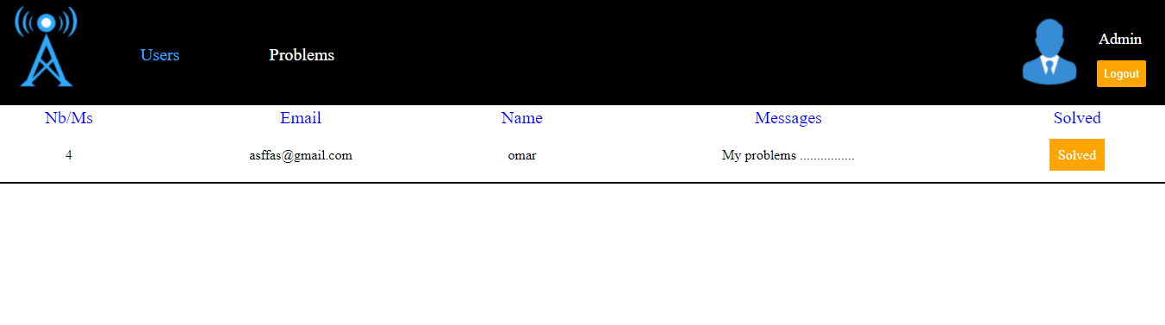

Finally, if you click on the logout button, you will go to the login page.